Project Design Phase-I Solution Architecture

|  |  |
| --- | --- |
| Date | 18 October 2022 |
| Team ID | PNT2022TMID40725 |
| Project Name | Project – Smart Farmer-IoT Enabled smart  Farming Application |
| Maximum Marks | 4 Marks |

**Solution Architecture:**

* The different soil parameters (temperature, humidity, light intensity, pH level) are sensed using different sensors and the obtained value is stored in IBM cloud.
* Arduino uno is used as a processing unit which processes the data obtained fromsensors and weather data from weather API.
* Node red is used as a programming tool to wire the hardware, software and APIs.The MQTT protocol is followed for communication.
* All the collected data are provided to the user through a mobile application which was developed using MIT app inventor. The user could make decision through an app, whether to water the crop or not depending upon the sensorvalues.

**Solution Architecture Diagram:**

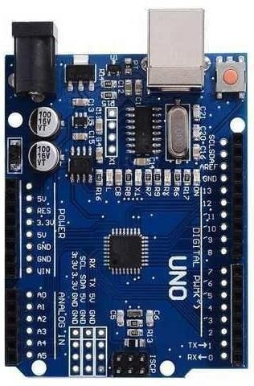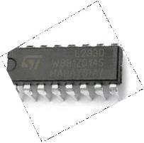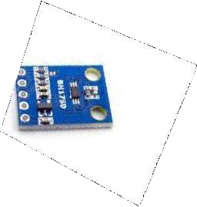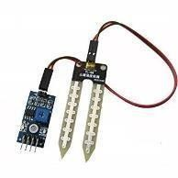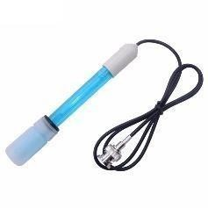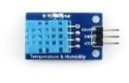

**TEMPERATURE AND HUMIDITY SENSOR**

**ARDUINO-UNO**

**L293D (16 PIN IC )**

**SOIL MOISTURE SENSOR**

**IBM IoT CLOUD**

**MOBILE APP**

**LIGHT INTENSITY SENSOR**

**pH SENSOR**

**OPEN WEATHER API**